3G/GPRS + GPS Shield For Arduino:

<https://www.youtube.com/watch?v=MqfvqKfwDYQ>

**Published on Aug 21, 2012**

The new 3G shield for Arduino enables the connectivity to high speed WCDMA and HSPA cellular networks in order to make possible the creation of the next level of worldwide interactivity projects inside the new "Internet of Things" era. It supports: photo and video recording, HTTP, FTP, POP3, SMTP, TCP/IP, UDP/IP connections among other features such as assisted-mobile (A-GPS) and mobile-based (S-GPS) modes.

3G Shield

3G/GPRS Shield

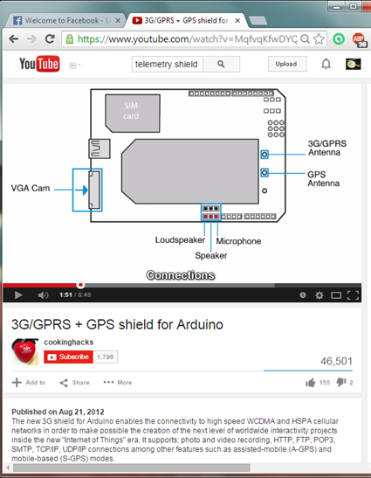

http://www.cooking-hacks.com/documentation/tutorials/arduino-3g-gprs-gsm-gps

Preliminary research: Telemetry

Receiver: FL electronics

Marshal 100 receiver and antenna

Marshal 800 receiver and antenn

Transmitter

Many modern telemetry systems take advantage of the low cost and ubiquity of GSM networks by using SMS to receive and transmit telemetry data

GSM:

Global System for Mobile Communications